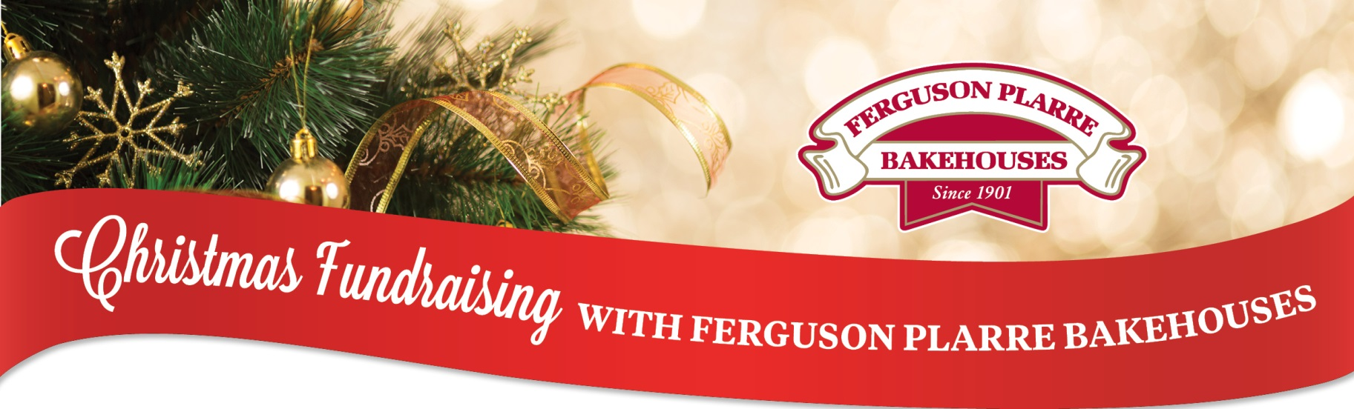
Please feel free to personalise this form and use it to help promote your fundraiser & raise funds!
STEPS TO FOLLOW:
- Update the red sections with your information and change the colour to black
- Delete any parts of this document that you don’t want
OR Cut and paste the bits you want into your own letter or email.
<insert date >
Dear Members (or maybe friends, students or families)
We are running a Ferguson Plarre Bakehouses Christmas fundraising drive to raise money for <insert your organisation, group or charity>. Attached is an order form. We really hope you will be able to collect some orders for us.
Ferguson Plarre Bakehouses is a proud, 4th generation family business that has been baking for over 120 years. Like all of their products, their Mince Tarts are time tested and made with the very best ingredients and always Australian sourced when possible.
Because Ferguson Plarre products are so well known in Melbourne we encourage you to hand your order form around to friends, family and work colleagues. You will probably find that they are enthusiastic to purchase from you, so they can also enjoy the famous Ferguson Plarre products and help out <insert your organisation, group or charity>.
Obviously the more products we sell, the more funds we will have to spend, so it would be great if every member could support us. If every member could sell just 4 Christmas Tart packs each, we would raise in excess of $000 (change this comment or amounts to suit your group’s size & plans)
Please return orders together with the relevant money to <insert location or person> by <date>.
Orders will be available for collection on <date> <insert location, time etc if you wish>.
Thank you in anticipation of your support for our Ferguson Plarre Christmas Fundraiser. Good luck and we hope you raise plenty of money for <insert your organisation, group or charity>!!
Sincerely,
<insert organisers name>

